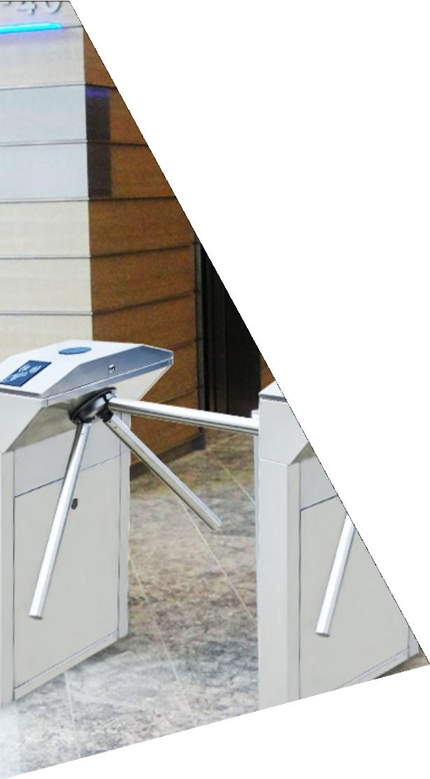
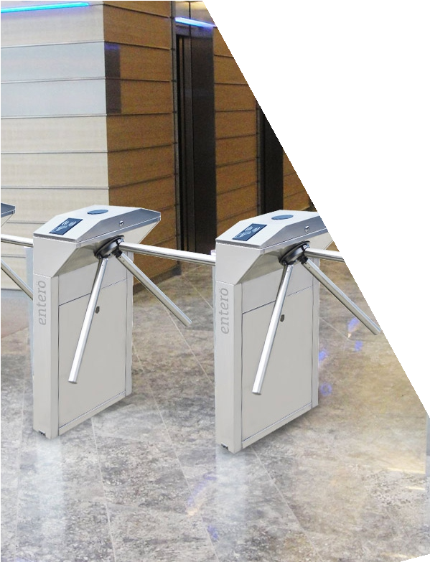
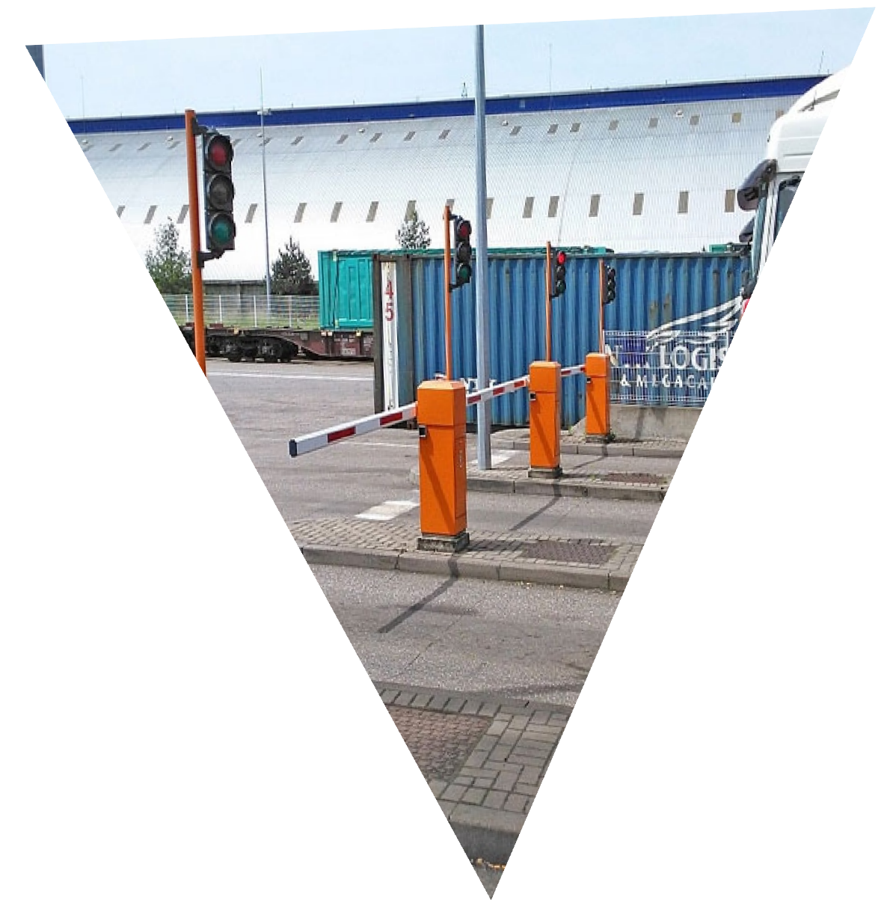
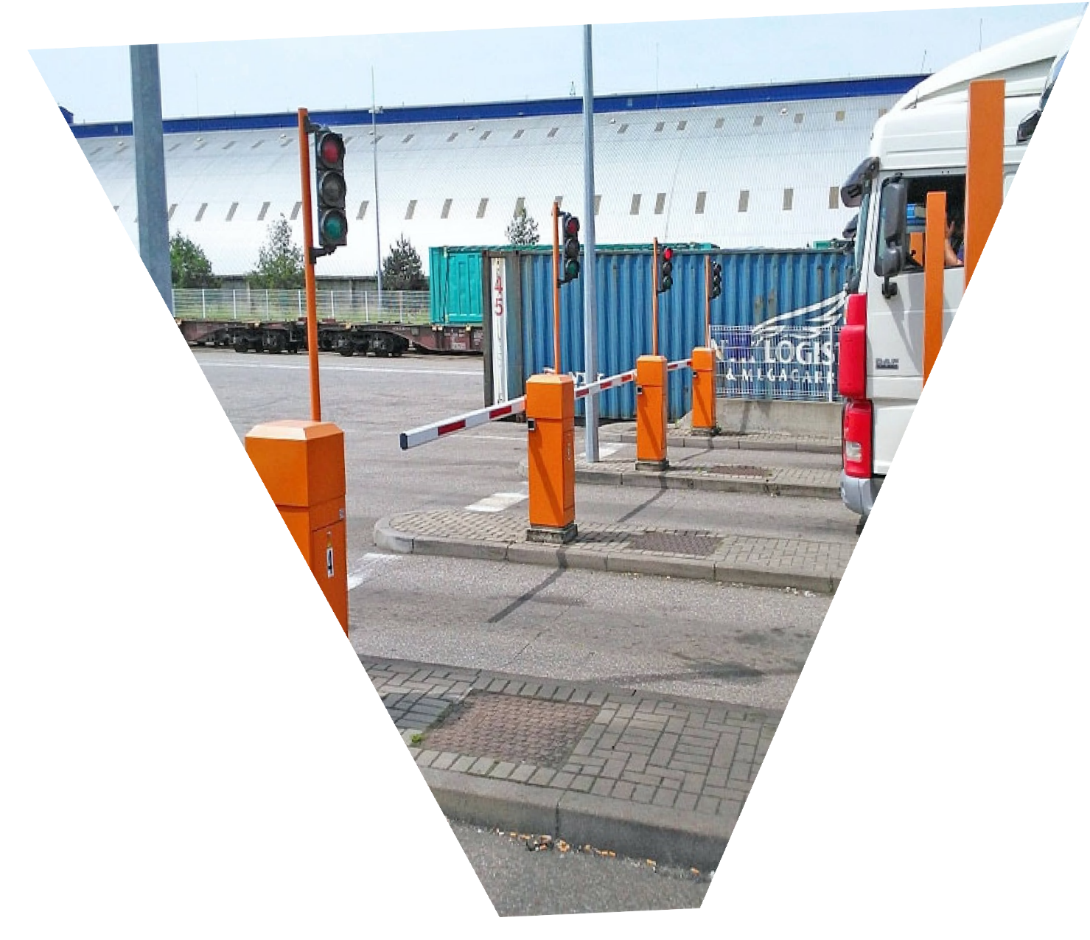
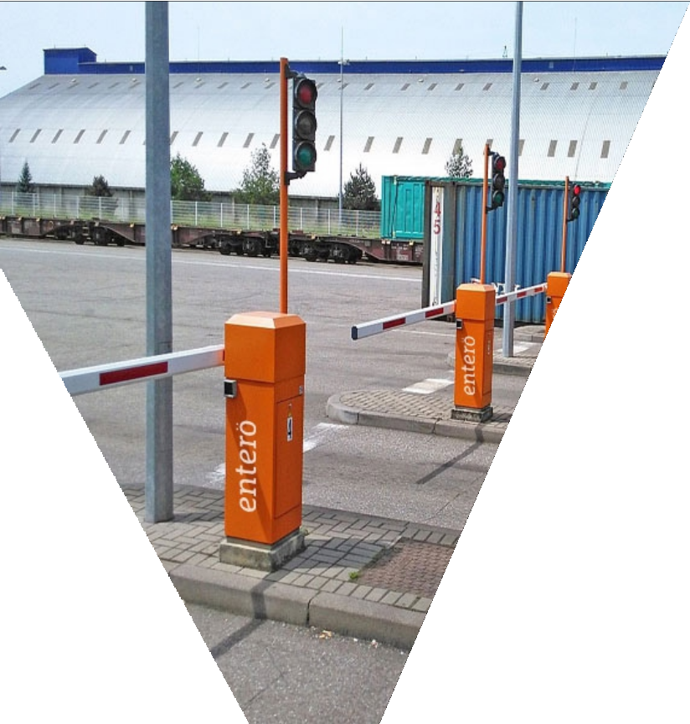
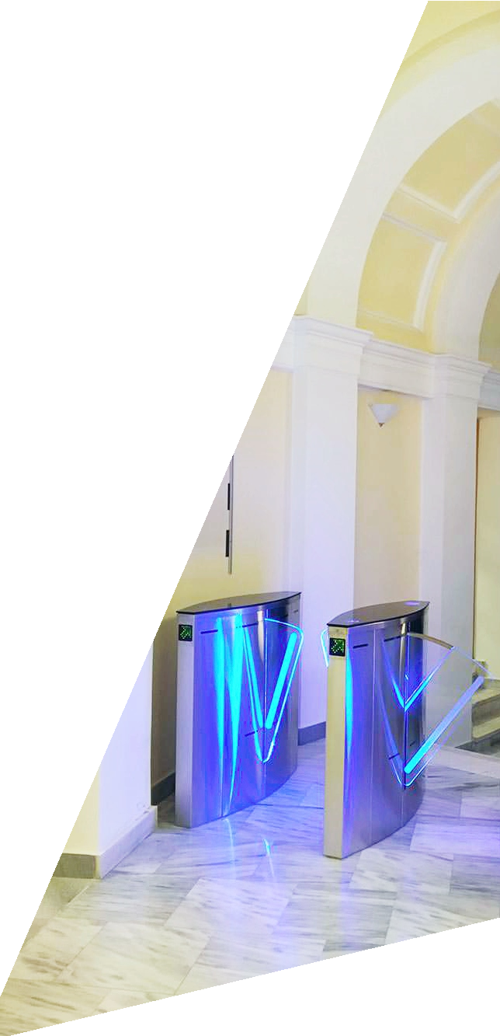

en er

e nt ra n ce a u t omatio n

SMART & SECURE ENTRANCE SOLUTIONS
















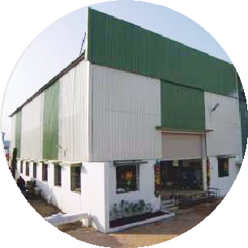
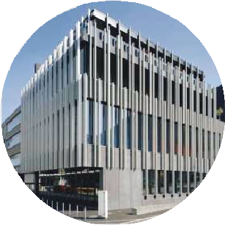




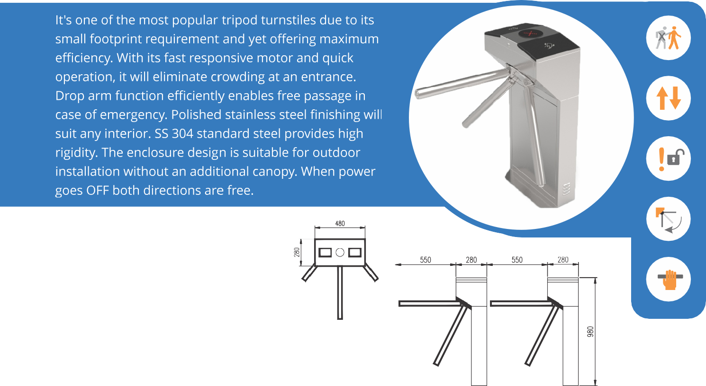
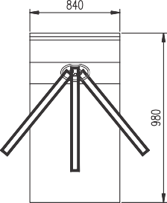

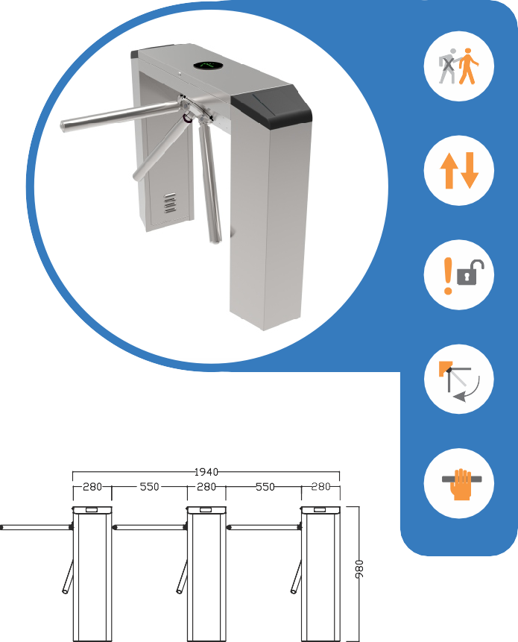
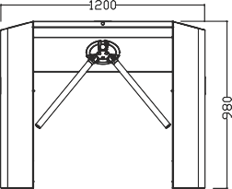
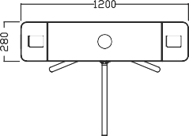

Size (L x B x H) | 480 x 280 x 980 mm
Unlock Time | 0.2 Sec
Pass Rate | 35 person / min
Pass Width | 550 mm
Weight | 45 Kg
Mode | Fail Safe
Power Consumption | 30 W
Driving voltage | 24 V

Size (L x B x H) | 1200 x 280 x 980 mm
Unlock Time | 0.2 Sec
Pass Rate | 35 person / min
Pass Width | 550 mm
Weight | 200 Kg
Mode | Fail Safe
Power Consumption | 30 W
Driving voltage | 24 V




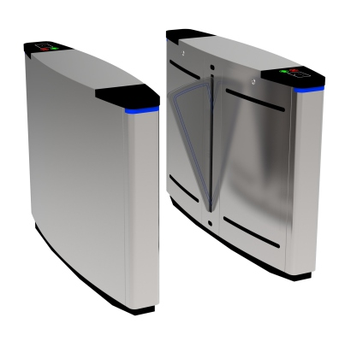




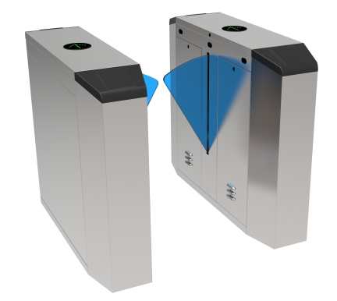





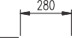
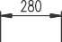

Size (L x B x H) | 1400 x 280 x 980 mm
Unlock Time | 0.2 Sec
Pass Rate | 35 person / min
Pass Width | 550 mm
Mechanism | Motorized
Frame Work | SS 304/316
Power Consumption | 35 W
Driving voltage | 24 V

Size (L x B x H) | 1400 x 280 x 980 mm
Unlock Time | 0.2 Sec
Pass Rate | 35 person / min
Pass Width | 550 mm
Weight | 120 Kg
Mode | Fail Safe
Power Consumption | 30 W
Driving voltage | 24 V





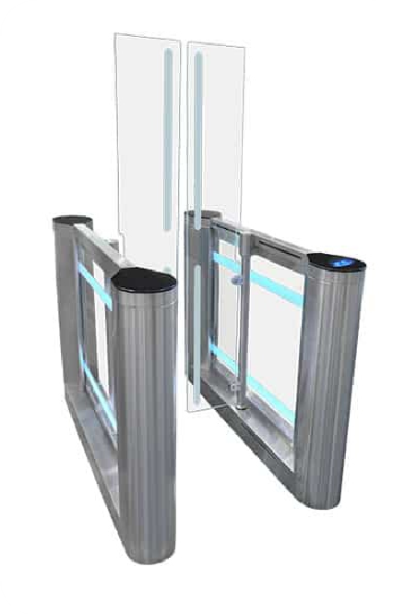


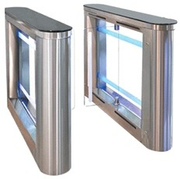


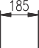
Size (L x B x H) | 1400 x 190 x 1020 mm
Unlock Time | 0.2 Sec
Pass Rate | 35 person / min
Pass Width | 550 mm
Weight | 200 Kg
Power Consumption | 35W
Frame work | SS 304/316
Driving voltage | 24 V

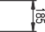
Size (L x B x H) | 1435 x 930 x 1800 mm
Unlock Time | 0.2 Sec
Pass Rate | 30 person / min
Pass Width | 900 mm
Weight | 190 Kg
Mechanism | Motorized
Frame Work | SS 304/316
Driving voltage | 24 V

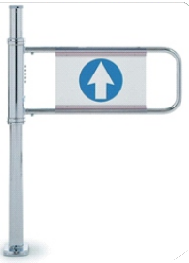

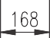


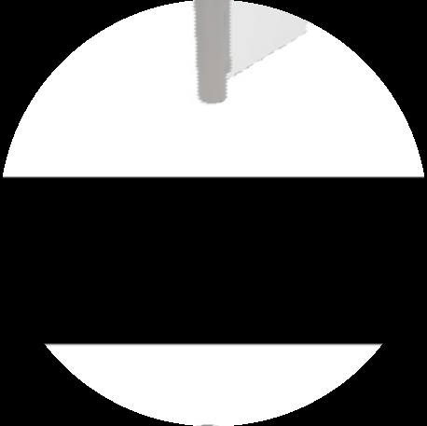
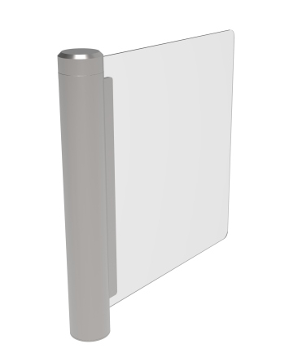

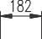

Size (L x B x H) | 168 x 600 x 1050 mm
Unlock Time | 0.2 Sec
Pass Rate | 30 person / min
Pass Width | 900 mm
Weight | 48 Kg
Mechanism | Motorized
Frame Work | SS 304/316
Driving voltage | 24 V

Size (L x B x H) | 182 x 1000 mm
Unlock Time | 0.2 Sec
Pass Rate | 35 person / min
Pass Width | 900 mm
Weight | 48 Kg
Mechanism | Servo Motor
Frame Work | SS 304/316
Driving voltage | 24 V


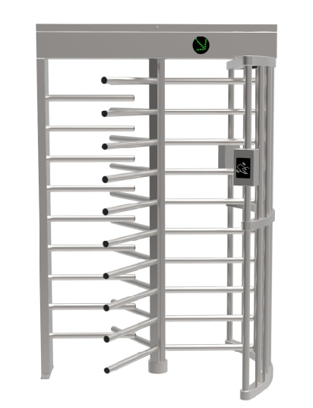
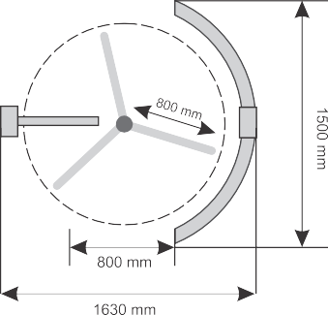





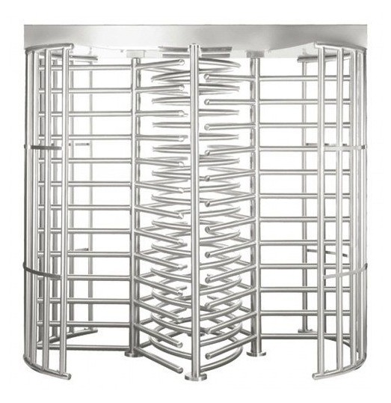
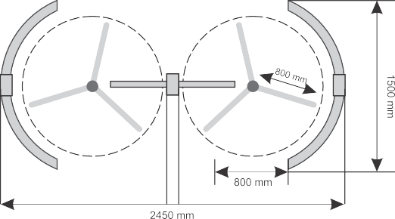


Size (L x B x H) | 1630 x 1500 x 2310 mm
Unlock Time | 0.2 Sec
Pass Rate | 35 person / min
Pass Width | 650 mm
Weight | 200 Kg
Mode | Fail Safe
Frame work | SS 304/316
Driving voltage | 24 V

Size (L x B x H) | 2450 x 1500 x 2310 mm
Unlock Time | 0.2 Sec
Pass Rate | 35 person / min
Pass Width | 650 mm
Weight | 400 Kg
Mode | Fail Safe
Frame work | SS 304/316
Driving voltage | 24 V

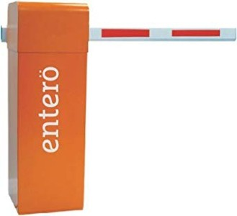

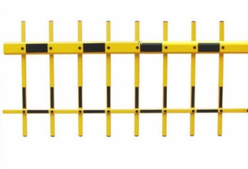
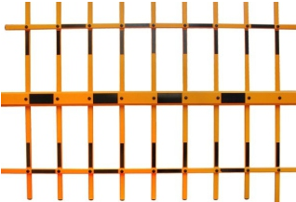

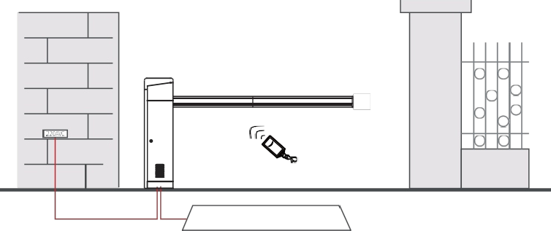
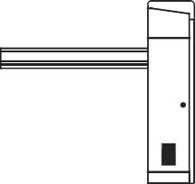
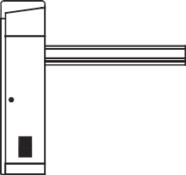


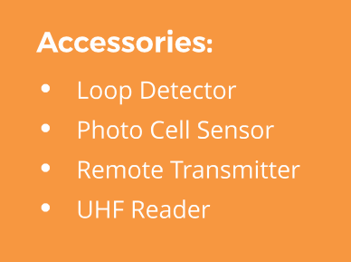

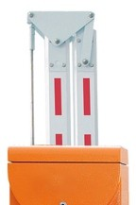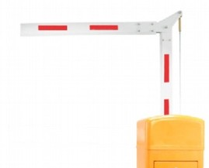
Arm Length | 1 m to 6 m
Rated Power | 80 W
Speed | 0.6s, 1s, 1.6s, 3s, 4s, 6s
IP Rate | 54
Weight | 48 Kg
Operation | Left & Right
Material | Aluminium Alloy
RC Distance | < 30 m

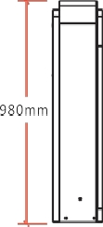



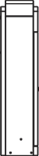





Car arrives at Entry Terminal
PARK THE CAR

Make payment at Exit Terminal

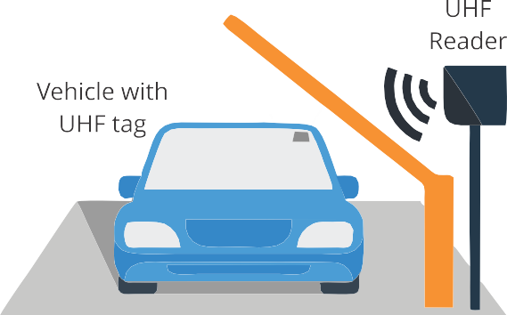
Boom Barrier

Press button and get the ticket

Boom Barrier will open

Boom Barrier

will open

Car exits the Parking premises





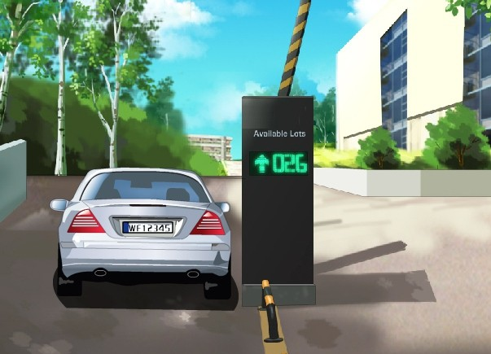

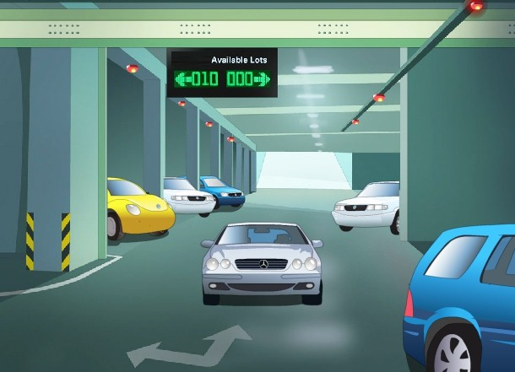





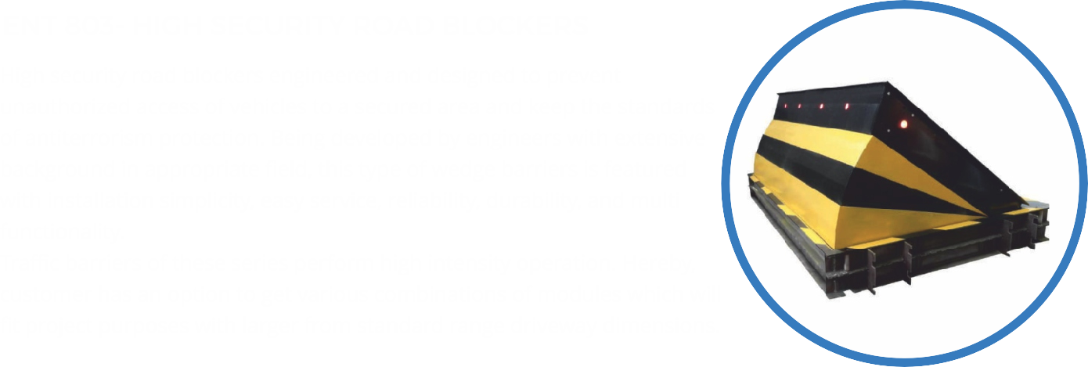

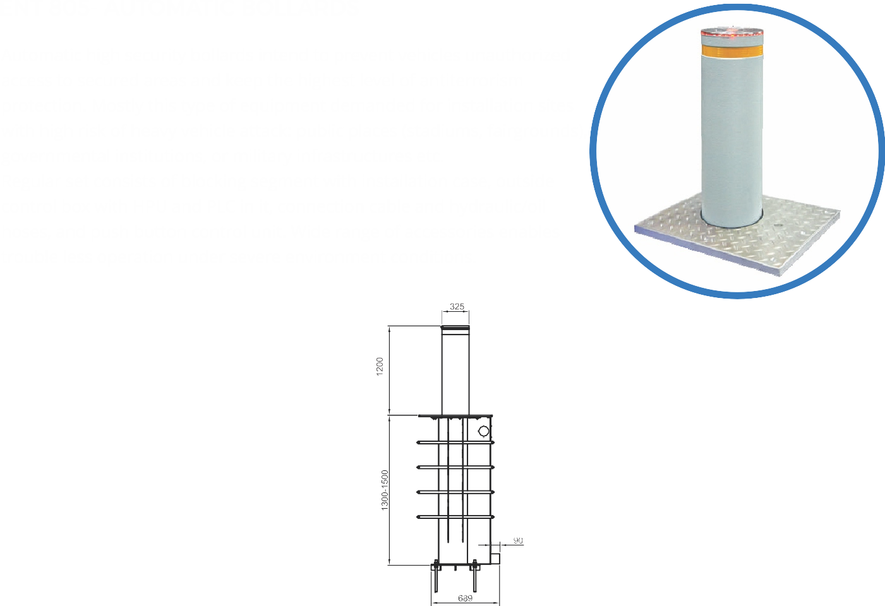
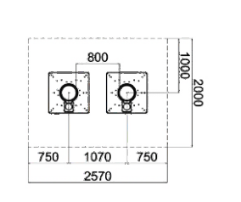
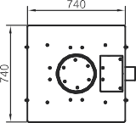

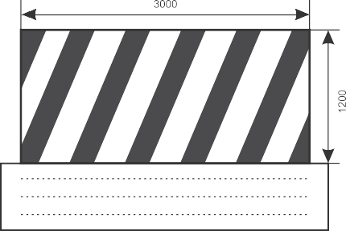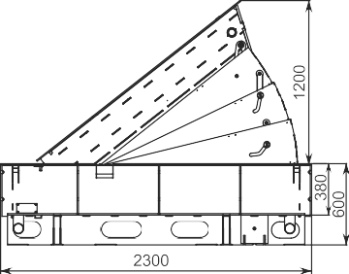
Height | 1200 mm
Width | 3000 mm
Drive | Hydraulic
Installation Type | Shallow Mounted
Rising Time | 3s, 5s
Lowering time | 2s, 5s
Material | Structural Steel
Power Supply | 3 phase 240V, 50/60 Hz

Tube Height | 1200 mm
Tube Diameter | 325 mm
Wall Thickness | 30 mm
Installation Type | Shallow Mounted
Rising Time | 312 mm /sec
Lowering time | 357 mm / sec
Power Supply | 3 phase 240V, 50/60 Hz

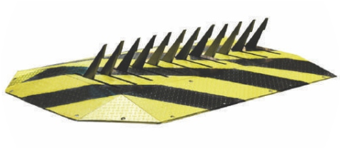



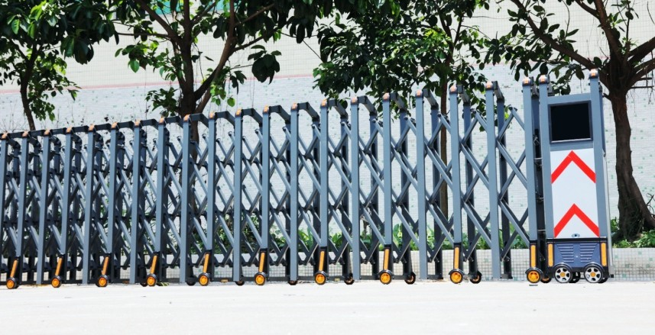
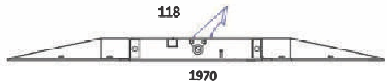
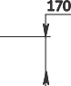
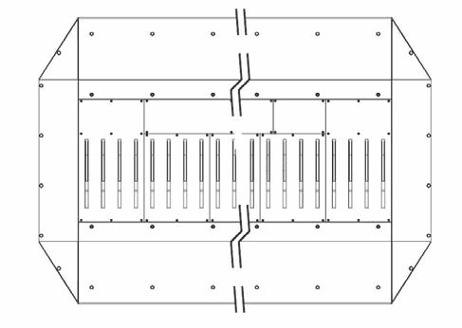
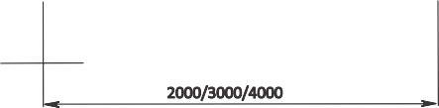

Spike Height | 170 mm
Width | 3000 mm
Drive | Hydraulic
Installation Type | Shallow Mounted
Rising Time | 3s
Lowering time | 2s
Material | Structural Steel
Power Supply | 3 phase 240V, 50/60 Hz







